**操作系统列表大全**

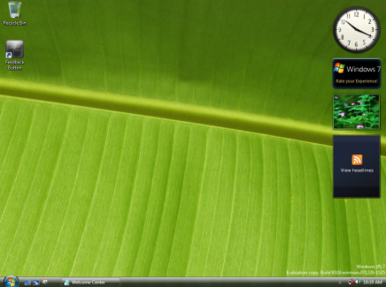

[Windows 7](http://www.techcn.com.cn/index.php?doc-innerlink-Windows%207) (2010)

[OLPC Sugar UI](http://www.techcn.com.cn/index.php?doc-innerlink-OLPC%20Sugar%20UI%20) (2007)

[Mac OS X v10.5 "Leopard"](http://www.techcn.com.cn/index.php?doc-innerlink-Mac%20OS%20X%20v10.5%20%22Leopard%22) (October 2007)

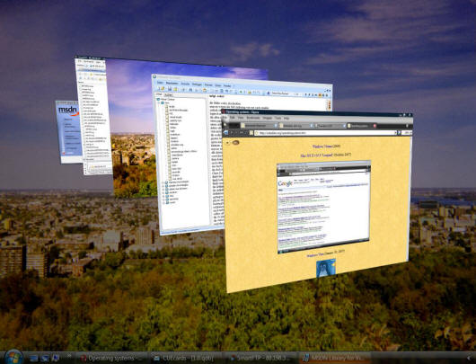

[Windows Vista](http://www.techcn.com.cn/index.php?doc-innerlink-Windows%20Vista) (January 30, 2007)

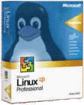

Novell and Microsoft announced a joint patent agreement to cover their respective products (November 2, 2006)

[Compiz](http://www.techcn.com.cn/index.php?doc-innerlink-Compiz)

[Parallels Workstation](http://www.techcn.com.cn/index.php?doc-innerlink-Parallels%20Workstation)

Novell acquired [SuSE](http://www.techcn.com.cn/index.php?doc-innerlink-SuSE) (January 2004)

[XP Service Pack 2](http://www.techcn.com.cn/index.php?doc-innerlink-XP%20Service%20Pack%202) (August 6, 2004)

[Windows Server 2003](http://www.techcn.com.cn/index.php?doc-innerlink-Windows%20Server%202003) (April 24, 2003)

[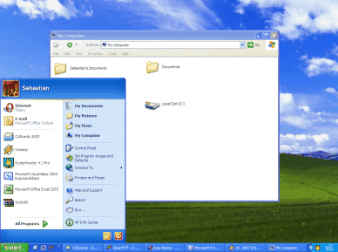](http://www.wincustomize.com/)

[Windows XP](http://www.techcn.com.cn/index.php?doc-innerlink-Windows%20XP) (October 25, 2001)

[DistroWatch](http://www.techcn.com.cn/index.php?doc-innerlink-DistroWatch) (May 31, 2001)

[Linux 2.4.0](http://www.techcn.com.cn/index.php?doc-innerlink-Linux%202.4.0) (January 4, 2001)

[Darwin](http://www.techcn.com.cn/index.php?doc-innerlink-Darwin) (2000)

[Windows Me](http://www.techcn.com.cn/index.php?doc-innerlink-Windows%20Me) (September 14, 2000)

[Windows 2000](http://www.techcn.com.cn/index.php?doc-innerlink-Windows%202000) (February 2000)

[Gnome](http://www.techcn.com.cn/index.php?doc-innerlink-Gnome) (1999)

[Wizards of OS](http://www.techcn.com.cn/index.php?doc-innerlink-Wizards%20of%20OS) (1999)

[Linux From Scratch](http://www.techcn.com.cn/index.php?doc-innerlink-Linux%20From%20Scratch) (1999)

[VMware Workstation](http://www.techcn.com.cn/index.php?doc-innerlink-VMware%20Workstation)

[Windows 98](http://www.techcn.com.cn/index.php?doc-innerlink-Windows%2098) (June 25, 1998)

[http://www.techcn.com.cn/uploads/201001/1263794293kIOIMy3N.png](http://kde-files.org/CONTENT/content-files/44218-linuxdistrotimeline-7.2.png)

[the Linux Distro Timeline](http://www.techcn.com.cn/index.php?doc-innerlink-the%20Linux%20Distro%20Timeline) (1998)

[Virtual PC](http://www.techcn.com.cn/index.php?doc-innerlink-Virtual%20PC) (June 1997)

[GTK+](http://www.techcn.com.cn/index.php?doc-innerlink-GTK+) (1997)

[Java Desktop System](http://www.techcn.com.cn/index.php?doc-innerlink-Java%20Desktop%20System)

[kde](http://www.techcn.com.cn/index.php?doc-innerlink-kde) (1996)

[Linux 2.0.0](http://www.techcn.com.cn/index.php?doc-innerlink-Linux%202.0.0) (June 9, 1996)

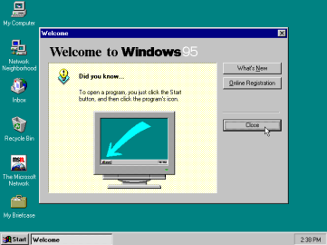

[Windows 95](http://www.techcn.com.cn/index.php?doc-innerlink-Windows%2095) (August 24, 1995)

[beos](http://www.techcn.com.cn/index.php?doc-innerlink-beos) (1995)

[Debian](http://www.techcn.com.cn/index.php?doc-innerlink-Debian) (1993)

[OS/2 Warp](http://www.techcn.com.cn/index.php?doc-innerlink-OS/2%20Warp) (1994)

[Suse](http://www.techcn.com.cn/index.php?doc-innerlink-Suse) (1994)

[Magic Cap](http://www.techcn.com.cn/index.php?doc-innerlink-Magic%20Cap) (1994)

[Copland](http://www.techcn.com.cn/index.php?doc-innerlink-Copland) (1994)

http://www.techcn.com.cn/uploads/201001/12637942931Ren23Dt.png

[Qt](http://www.techcn.com.cn/index.php?doc-innerlink-Qt) (1994)

[OpenStep](http://www.techcn.com.cn/index.php?doc-innerlink-OpenStep) (1993)

[Common Desktop Environment](http://www.techcn.com.cn/index.php?doc-innerlink-Common%20Desktop%20Environment) (1993)

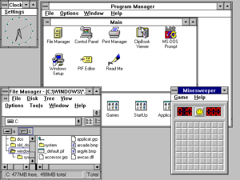

[Windows 3.1](http://www.techcn.com.cn/index.php?doc-innerlink-Windows%203.1) (August 1992) was released two years after Version 3.0

[Linux](http://www.techcn.com.cn/index.php?doc-innerlink-Linux) (September 1991)

[Windows 3.0](http://www.techcn.com.cn/index.php?doc-innerlink-Windows%203.0) (May 22, 1990)

[geos](http://www.techcn.com.cn/index.php?doc-innerlink-geos) (1990)

[openwindows](http://www.techcn.com.cn/index.php?doc-innerlink-openwindows) (1989)

[the NEXTSTEP operating system](http://www.techcn.com.cn/index.php?doc-innerlink-the%20NEXTSTEP%20operating%20system) (September 18, 1989)

[Posix](http://www.techcn.com.cn/index.php?doc-innerlink-Posix) (1988)

[open look](http://www.techcn.com.cn/index.php?doc-innerlink-open%20look) (late 1980s)

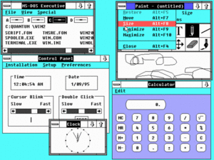

[Windows 2.0](http://www.techcn.com.cn/index.php?doc-innerlink-Windows%202.0) (December 9, 1987) was released, with icons & overlapping windows

[OS/2 1.0](http://www.techcn.com.cn/index.php?doc-innerlink-OS/2%201.0) (December 1987)

[IBM AIX](http://www.techcn.com.cn/index.php?doc-innerlink-IBM%20AIX) (1986)

[GEOS](http://www.techcn.com.cn/index.php?doc-innerlink-GEOS) (1986)

[lynxos](http://www.techcn.com.cn/index.php?doc-innerlink-lynxos) (1986)

[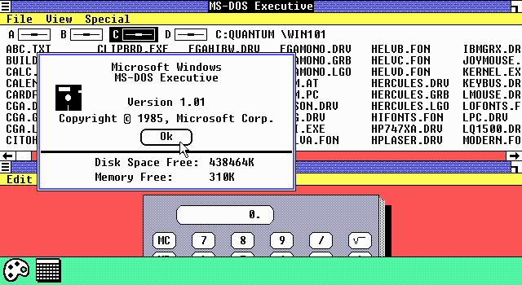](http://e-ducation.net/microsoft.htm)

[Microsoft Windows 1.0](http://www.techcn.com.cn/index.php?doc-innerlink-Microsoft%20Windows%201.0) (November 1985) was Microsoft's first attempt to implement a  
multitasking graphical user interface-based operating environment on the PC platform.

[Desq](http://www.techcn.com.cn/index.php?doc-innerlink-Desq) (July 1985)

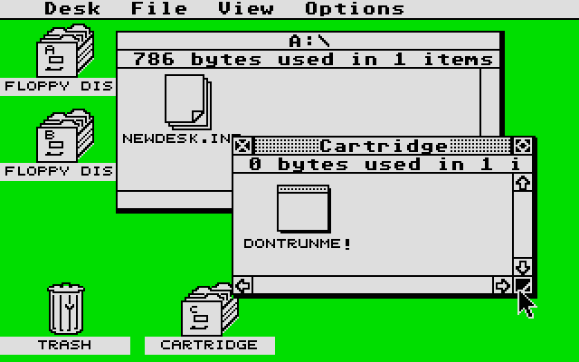

[Atari TOS](http://www.techcn.com.cn/index.php?doc-innerlink-Atari%20TOS) (1985)

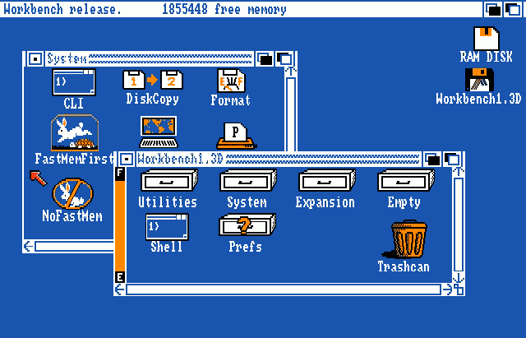

[AmigaOS](http://www.techcn.com.cn/index.php?doc-innerlink-AmigaOS) (1985)

[TopView](http://www.techcn.com.cn/index.php?doc-innerlink-TopView) (1985)

[GEM](http://www.techcn.com.cn/index.php?doc-innerlink-GEM) (1985)

[Plan 9 from Bell Labs](http://www.techcn.com.cn/index.php?doc-innerlink-Plan%209%20from%20Bell%20Labs) (mid-1980s)

[V](http://www.techcn.com.cn/index.php?doc-innerlink-V) (1980s)

[Motif](http://www.techcn.com.cn/index.php?doc-innerlink-Motif) (1980s) is a graphical widget toolkit for building graphical user interfaces under the X Window System on Unix

[the TRON Project](http://www.techcn.com.cn/index.php?doc-innerlink-the%20TRON%20Project) (1984)

[X Window System](http://www.techcn.com.cn/index.php?doc-innerlink-X%20Window%20System) (1984)

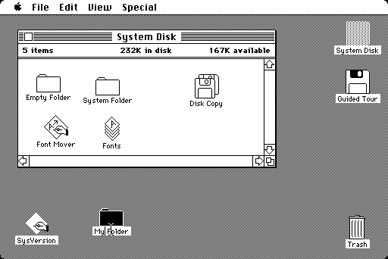

[Macintosh's System 1.0](http://www.techcn.com.cn/index.php?doc-innerlink-Macintosh's%20System%201.0) (January 24, 1984)

[HP-UX](http://www.techcn.com.cn/index.php?doc-innerlink-HP-UX) (1983)

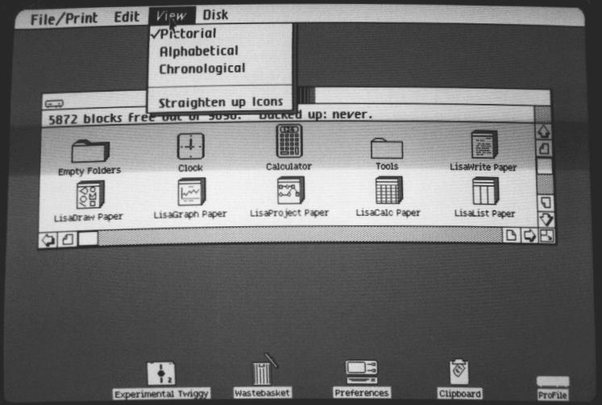

[the Apple Lisa](http://www.techcn.com.cn/index.php?doc-innerlink-the%20Apple%20Lisa) (January 1983) was the second computer with a graphical user interface

[SunOS 1.0](http://www.techcn.com.cn/index.php?doc-innerlink-SunOS%201.0) (1982)

[IRIX](http://www.techcn.com.cn/index.php?doc-innerlink-IRIX) (1982)

[qnx](http://www.techcn.com.cn/index.php?doc-innerlink-qnx) (1982)

[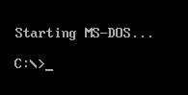](http://e-ducation.net/microsoft.htm)

[MS-DOS](http://www.techcn.com.cn/index.php?doc-innerlink-MS-DOS) (August 1981) was released with the first IBM PC

[QDOS](http://www.techcn.com.cn/index.php?doc-innerlink-QDOS) (1980)

[Xenix](http://www.techcn.com.cn/index.php?doc-innerlink-Xenix) (1979)

[ucsd pascal p system](http://www.techcn.com.cn/index.php?doc-innerlink-ucsd%20pascal%20p%20system) (1978)

[Berkeley Software Distribution](http://www.techcn.com.cn/index.php?doc-innerlink-Berkeley%20Software%20Distribution) (1977)

[cp/m](http://www.techcn.com.cn/index.php?doc-innerlink-cp/m) (1974)

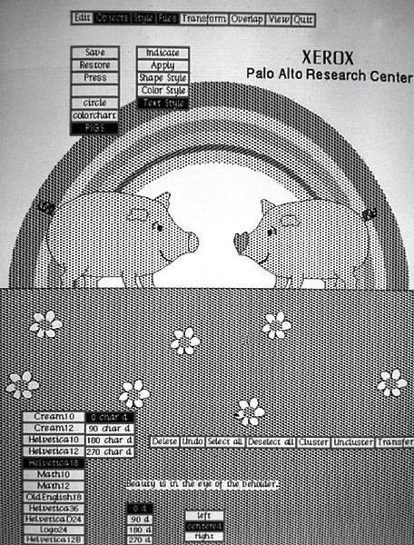

[the Xerox Alto](http://www.techcn.com.cn/index.php?doc-innerlink-the%20Xerox%20Alto) (1973) was the first personal computer and the first  
computer to use the desktop metaphor and graphical user interface (GUI)

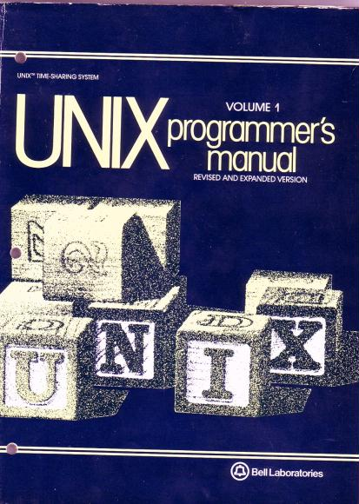

[Unix](http://www.techcn.com.cn/index.php?doc-innerlink-Unix) (1970) was officially named and ran on the PDP-11/20. The operating

system was developed in the 1960s by a group of AT&T Bell Labs employees

[Multics](http://www.techcn.com.cn/index.php?doc-innerlink-Multics) (1964)

[OS/360](http://www.techcn.com.cn/index.php?doc-innerlink-OS/360) (1964)

[GCOS](http://www.techcn.com.cn/index.php?doc-innerlink-GCOS) (1962)

[CTSS](http://www.techcn.com.cn/index.php?doc-innerlink-CTSS) (1961)

[IBSYS](http://www.techcn.com.cn/index.php?doc-innerlink-IBSYS) (1960)